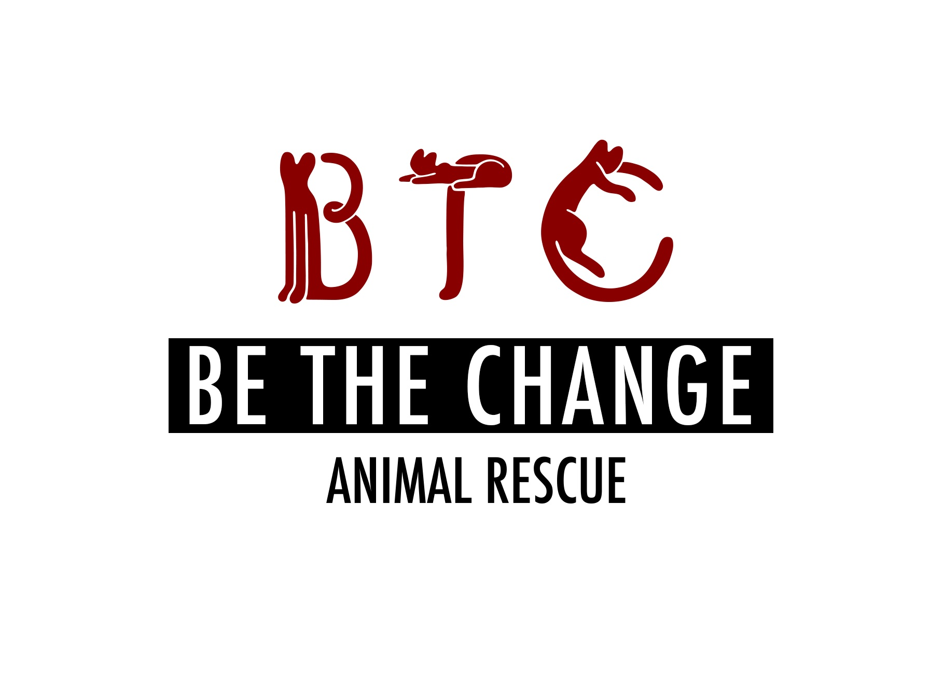

**Be The Change Animal Rescue Application For Dog Fostering**

Applicant name (first and last): *Please list first and last names of ALL people in home caring for animal

Address:

City, State: ZIP:

Home phone/ Cell:

E-mail:

Employer:

Occupation:

Age (age range is ok if you prefer):

Social media:

Facebook:

IG:

1. What is the name of the dog you are interested in fostering, if applicable?

2. If you do not have a particular dog/cat you are interested in fostering, please let us know what type of dog/cat are you interested in fostering. Circle any that apply: Male/Female; Long Hair/Short Hair; Color (black, tuxedo, tabby, orange, gray)

Older Dog; Younger Dog:

What size dog are you able to foster?

What type of personality would fit best in your home? Circle any that apply: affectionate; athletic; chill, hang back kinda dog

3. Would you be able to foster more than one dog/cat at a time? (We generally would not ask you to foster more than two cats at a time, but we have quite a few bonded kitty pairs ☺)

4. Are there specific dates that you would NOT be able to foster? (We work to find homes as quickly as possible, but we sometimes ask that they chill with their foster people for a couple weeks up to a couple months—but we are very happy to work around your schedule. Also, we are usually MORE than happy to let you adopt the animal if you fall for him or her—see question #22 ☺)

5. How many people currently reside in your household? What are their names (first and last) and relation to you?

6. Do any children live in the household or regularly spend time in the household? If so, please list their ages and relation to you:

7. Is everyone in your household in agreement with you fostering?

8. Is anyone your household allergic to cats/dogs?

9. Does your building or home allow you to have pets?

Do you rent or own?

For how long have you been at current residence?

Are you planning to move, and if so, when?

10. Do you currently have animals in your residence? If so, please describe all the other animals that you care for.

|  |  |  |  |  |  |
| --- | --- | --- | --- | --- | --- |
| Pet name | Breed (cat, dog, fish, bird, reptile) | Age& Sex | Spayed/  Neutered? | Temperament (aggressive, shy, friendly, playful) | If cat, what is FeLV status? |
|  |  |  |  |  |  |
|  |  |  |  |  |  |
|  |  |  |  |  |  |
|  |  |  |  |  |  |

11. Depending on the animal you foster for us, do you agree to work with us to integrate the new animal smoothly into your home? We typically recommend that adopters keep the new animal in a separate room (bathroom, bedroom) or crate if they have other pets or if the adopted animal is timid, for at least 2 days, but we might revise the recommendation depending on the pets’ personalities, living arrangements, etc.

12. Do you currently have any of the following? Circle any that apply:

Porch / terrace or balcony / window that does not have a screen / holes or cracks in your home (in the walls or flooring)/fireplace/ access to outdoor space/access to park / fenced in yard-if so, how tall is fence/ elevator/ stairs, if so, how many flights

13. Would you allow someone from BTCAR to visit your home by appointment or virtually to make sure it is suitable (ie: has screens on the windows, does not have holes in walls or lots of loose wires, fences or yards that are enclosed if the dog will be outside)?

14. If not currently, have you ever had a dog/cat?

15. Please describe all the animals you had but no longer care for:

|  |  |  |  |  |
| --- | --- | --- | --- | --- |
| Pet name | Breed (cat, dog, fish, bird, reptile) | How long did you have the pet? | Spayed/  Neutered? | Why is the pet no longer in your care? Age at passing if applicable. |
|  |  |  |  |  |
|  |  |  |  |  |
|  |  |  |  |  |

16. Would you allow the foster dog to go outdoors unsupervised?

How much time would the dog spend out doors?

How many walks would you be able to do?

17. How many hours are you away from your home on a typical day?

18. Would you be willing to help socialize a foster dog? (For example, if we have determined that the foster dog is not friendly enough for adoption, would you be willing to do some training with treats, clicker training, etc? We can help with these different strategies—and provide the treats and supplies ☺)

19. If any behavioral problems arise or the animal turns out to be unsuitable for you, do you agree to communicate the issues to BTCAR and return to BTCAR asap if necessary or work with us to hold the dog while we find appropriate placement? We are a foster based rescue and sometimes takes a few days to move an animal.

20. Would you be able to help us find a permanent home for the dog? (We do not require fosters to help in this way, but certainly love it if they can! This help could involve a range of activities, from letting your friends and coworkers know about your foster and raving about him/her on social media to bringing the foster to weekend adoption events at pet stores near you—we could help connect you with those events.)

21. Do you agree to allow BTCAR to take the foster back from you as soon as possible if we find a suitable permanent home?

22. Do you agree to fill out paperwork (an adoption application) with BTCAR in the happy event that you would like to adopt?

23. Do you agree not to hold BTCAR responsible if the dog scratches or bites or otherwise harms furniture or a resident or guest in your home? (We work to connect foster homes with friendly, sweet animals but even the best of us can be cranky some days.)

24. Could you please provide the names and numbers or email addresses of three references? If you currently have pets WE NEED NAME OF VET

Contact #1 VETERINARIAN if applicable:

Contact #2-

Contact #3-

Additional questions for DOG applicants:

1-Have you ever had animals with health or behavioral issues? Please elaborate:

2-Are you able and willing to provide care for special needs animals which may include medications, medicated baths, and special dietary needs?

Thank you very much!