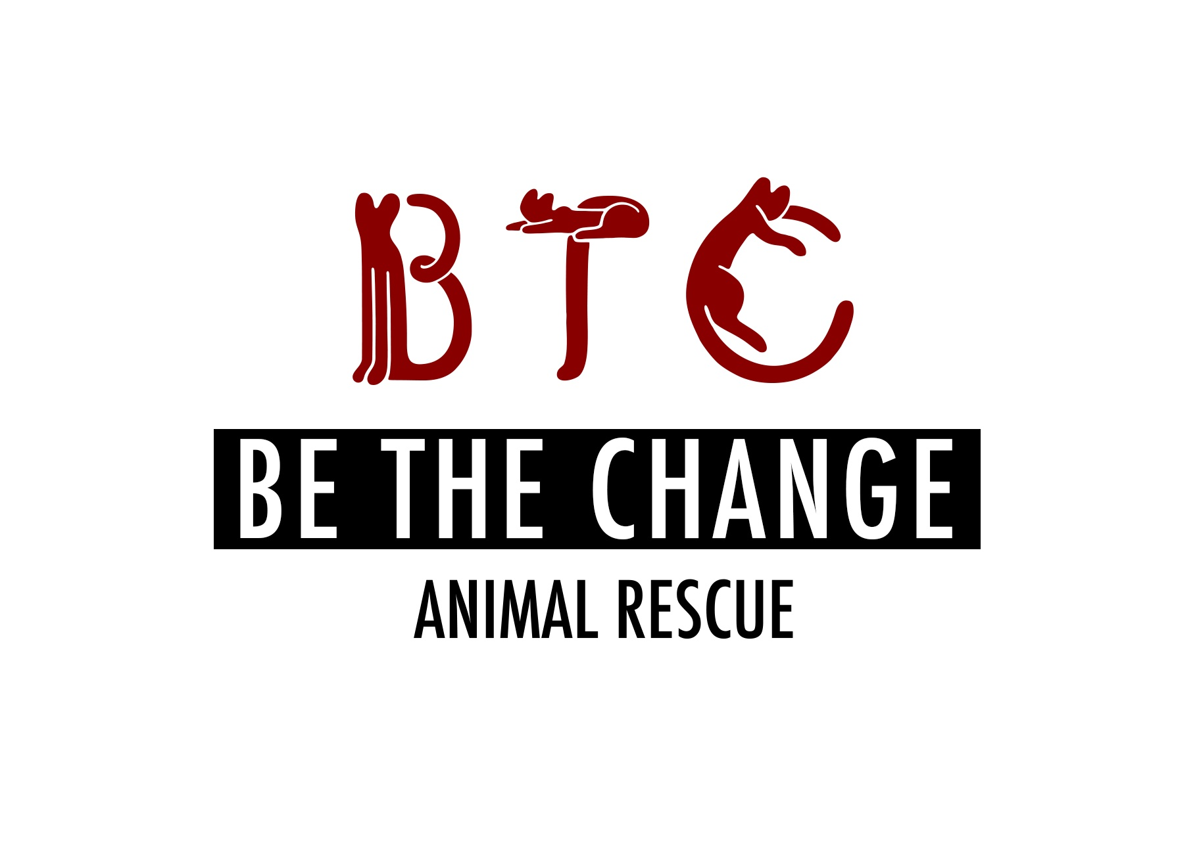

**Be The Change Animal Rescue Application For Cat Fostering**

**\*If more than one person if primary caretaker, please give info for all**

Applicant name (first and last):

Address:

City, State: ZIP:

Home phone/ Cell:

E-mail:

Employer:

Occupation:

Social Media:

FB:

IG:

LinkedIN:

Age (age range is ok if you prefer):

1. What is the name of the cat you are interested in fostering, if applicable?

2. If you do not have a particular cat you are interested in fostering, please let us know what type of cat are you interested in fostering. Circle any that apply: Male/Female; Long Hair/Short Hair; Color (black, tuxedo, tabby, orange, gray)

What type of personality would fit best in your home? Circle any that apply: affectionate lap cat; playful explorer; chill, hang back kinda cat

3. Would you be able to foster more than one cat at a time? (We generally would not ask you to foster more than two cats at a time, but we have quite a few bonded kitty pairs ☺)

4. Are there specific dates that you would NOT be able to foster? (We work to find the cats homes as quickly as possible, but we sometimes ask that they chill with their foster people for a couple weeks up to a couple months—but we are very happy to work around your schedule. Also, we are usually MORE than happy to let you adopt the cat if you fall for him or her—see question #22 ☺)

5. How many people currently reside in your household? What are their names (first and last) and relation to you?

6. Do any children live in the household or regularly spend time in the household? If so, please list their ages and relation to you:

7. Is everyone in your household in agreement with you fostering a cat or cats?

8. Is anyone your household allergic to cats?

9. Does your building or home allow you to have pets?

10. Do you currently have animals in your residence? If so, please describe all the other animals that you care for.

|  |  |  |  |  |  |
| --- | --- | --- | --- | --- | --- |
| Pet name | Breed (cat, dog, fish, bird, reptile) | Age& Sex | Spayed/  Neutered? | Temperament (aggressive, shy, friendly, playful) | If cat, what is FeLV status? |
|  |  |  |  |  |  |
|  |  |  |  |  |  |
|  |  |  |  |  |  |
|  |  |  |  |  |  |

11. Depending on the cat you foster for us, do you agree to work with us to integrate the new cat smoothly into your home? We typically recommend that adopters keep the new cat in a separate room (bathroom, bedroom) if they have other pets or if the adopted cat is timid for at least 2 days, but we might revise the recommendation depending on the pets’ personalities, living arrangements, etc.

12. Do you currently have any of the following? Circle any that apply:

Porch / terrace or balcony / holes or cracks in your home (in the walls or flooring)/ fireplace/ window that does not have a screen / gas stove knobs /window a/c

\***Adjustable window screens are NOT cat safe.** If you do not have full custom window screens we can help you make the windows kitty safe with limiters and other materials. Are you willing to invest in making windows cat safe?

\***Accordion screens on the side of window air conditioning units often need reinforcement as cats can easily push through**. Are you willing to make appropriate enhancements if needed?

13. Would you allow someone from BTCAR to visit your home by appointment to make sure it is suitable for a cat (ie, has screens on the windows, does not have holes in walls or lots of loose wires)?

14. If not currently, have you ever had a cat?

15. Please describe all the animals you had but no longer care for:

|  |  |  |  |  |
| --- | --- | --- | --- | --- |
| Pet name | Breed (cat, dog, fish, bird, reptile) | How long did you have the pet? | Spayed/  Neutered? | Why is the pet no longer in your care? |
|  |  |  |  |  |
|  |  |  |  |  |
|  |  |  |  |  |

16. Would you allow the foster cat to go outdoors?

17. How many hours are you away from your home on a typical day?

18. Would you be willing to help socialize a foster cat? (For example, if we have determined that the foster cat is not friendly enough for adoption, or the foster cat does not start to approach you or let you approach him after a week or so, would you be willing to do some training with treats, clicker training, etc? We can help with these different strategies—and provide the treats and supplies ☺)

19. If any behavioral problems arise or the cat turns out to be unsuitable for you, do you agree to communicate the issues to BTCAR and return to BTCAR asap if necessary?

20. Would you be able to help us find a permanent home for the cat? (We do not require fosters to help in this way, but certainly love it if they can! This help could involve a range of activities, from letting your friends and coworkers know about your foster cat and raving about him/her on social media to bringing the foster cat to weekend adoption events at pet stores near you—we could help connect you with those events.)

21. Do you agree to allow BTCAR to take the foster cat back from you as soon as possible if we find a suitable permanent home for the cat?

22. Do you agree to fill out paperwork (an adoption application/fee) with BTCAR in the happy event that you would like to adopt the cat?

23. Do you agree not to hold BTCAR responsible if the cat scratches or bites or otherwise harms a resident or guest in your home? (We work to connect foster homes with friendly, sweet kitties, but even the best of us can be cranky some days.)

24. Could you please provide the names and numbers or email addresses of three references? These could be friends, coworkers, or family that we could quickly touch base with as a background check, FBI style ☺ **If you have or have had pets, please let us know the name of your vet—that can count as one of your references**. (We ask this of all our potential fosters and adopters.)

Contact #1-VETERINARIAN if Applicable

Contact #2-

Contact #3-

25. By signing this form, I/we acknowledge that all information on this form is true and correct. I/we understand that any misrepresentation of fact may result in to BTCAR refusing foster/adoption privileges to me/us. If my/our request for foster/adoption is approved and later BTCAR discovers the above information is not true or correct, to BTCAR reserves the right to remove the foster/adopted cat from my home.

Thank you very much!