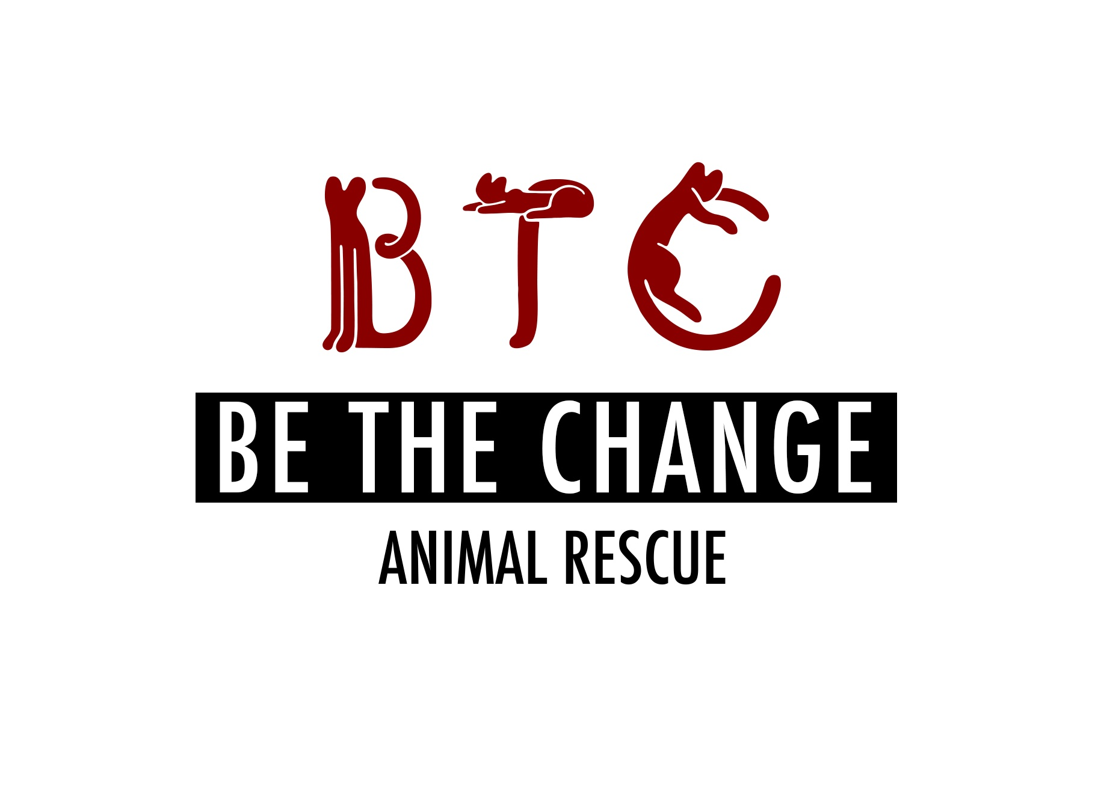

**Be The Change Animal Rescue Application (BTCAR) For Adoption**

Applicant name (first and last):

Preferred pronouns (she/her, he/him, they/them):

Address:

City, State: ZIP:

Home phone/cell:

E-mail:

Employer:

Occupation:

Age:

Social Media:

Facebook:

LinkedIn:

IG:

1. What type of dog are you interested in?

(Male/Female), Personality type; Color/Size/Age (if applicable):

Or if you are interested in a specific dog name of dog you are interested in?

2. Please list the first and last names of ALL the people who reside in your household and your relationship to each other.

3. Any children in the household? If so, please list ages:

4. For whom are you adopting? (Self/Gift)

5. Does anyone in your household have any allergies to animals?

If yes, explain:

6. Who will be the primary caretaker

7. Where do you live? (Apartment/Condo/Farm/Mobile home/Townhouse/House)

8. Do you own or rent your residence? If you rent, what is name of landlord and phone number? Do you have any other residence(s) where the animal will spend time?

How long have you lived in this residence?

Are you moving, if so when?

9. Are companion animals allowed in your residence(s)?

10. Where will the dog be kept? (Indoors only/Outdoors only/Both in/out)

11. If outdoors, will the dog be attended or unattended.

What steps will you take to make sure the dog does not get away?

How much outdoors time will the dog get?

How many walks a day are you reasonably able to provide?

12. Do you currently have any of the following? Circle any that apply:

Porch / terrace or balcony / window that does not have a screen / holes or cracks in your home (in the walls or flooring)/ fireplace/fenced yard, if so how high is the fence/unfenced yard/ access to parks and outdoor space

13. Will anyone be home during the day?

14. How many hours will the dog be left unattended on a typical day?

15. When no one is home, where will the animal be kept?

16. If you move, what will you do with the animal?

17. If the dog/at is not spayed/neutered when you adopt, do you agree to be responsible for ensuring this animal is spayed/neutered by the age of 6 months? (It’s rare for us to adopt animals that are not spayed/neutered, and we will let you know if they are not.)

18. **If behavioral problems arise or the dog turns out to be unsuitable for you, do you agree to communicate the issues to BTCAR and return to BTCAR if necessary? Do you agree to NOT give the animal to any other person or rescue without communicating with us**?

19. Do you currently have any companion animals (cats, dogs, birds, fish, reptiles)?

20. Please describe all the companion animals that the cat you adopt from us will be in contact with.

|  |  |  |  |  |  |
| --- | --- | --- | --- | --- | --- |
| Pet name | Breed (cat, dog, fish, bird, reptile) | Age& Sex | Spayed/  Neutered? | Temperament (aggressive, shy, friendly, playful) | If cat, what is FeLV status? |
|  |  |  |  |  |  |
|  |  |  |  |  |  |
|  |  |  |  |  |  |
|  |  |  |  |  |  |

21. Depending on the dog you foster/adopt from us, do you agree to work with us to integrate the new friend smoothly into your home? We typically recommend that adopters keep the new dog in a separate room (bathroom, bedroom) or crate if they have other pets or if the adoptee is timid for at least 2 days, but we might revise the recommendation depending on the pets’ personalities, living arrangements, etc. We may make more specific recommendations, depending on the animal

22. Please describe all the companion animals you had had but no longer care for.

|  |  |  |  |  |
| --- | --- | --- | --- | --- |
| Pet name | Breed (cat, dog, fish, bird, reptile) | How long did you have the pet? | Spayed/  Neutered? | Why is the pet no longer in your care? |
|  |  |  |  |  |
|  |  |  |  |  |
|  |  |  |  |  |
|  |  |  |  |  |

23. Have you ever adopted an animal from a rescue/animal control agency? If so, do you remember the name and contact information for the group?

24. Have you ever had an application rejected for adoption of an animal from a rescue/animal control facility? If yes, which one and could you please explain the circumstances?

25. Are you financially able and willing to provide annual checkups, vaccinations, and ANY medical care necessary? (Annual veterinary care is typically $200-$300, and medical emergencies can run $300-$1000, sometimes more.) . Are you considering pet insurance?

26. Are you planning on devocalizing the dog you adopt from us?

27. Are you familiar with your local animal control laws?

28. Do you agree to permit a visit to your home/farm by appointment?

29. Do you agree not to hold BTCAR responsible if the dog/ scratches or bites or otherwise harms property or a resident or guest in your home? (We work to connect foster homes with friendly, sweet animals, but even the best of us can be cranky some days.)

30. Do you agree to pay the adoption fee?

Adoption fees for dogs range from $250-400? The donations are what keeps the rescue funded and able to cover some of the medical care and costs.

31. Are you willing to sign legal pet adoption papers?

32. Why do you want to adopt?

33. Have you ever had animals with health or behavioral issues? Please elaborate:

34. Are you able and willing to provide care for special needs animals which may include medications, medicated baths, and special dietary needs?

35. Could you please provide the names and numbers or email addresses of three references? These could be friends, coworkers, or family that we could quickly touch base with as a background check. **IF YOU HAVE/HAVE HAD A VETERINARIAN PLEASE PROVIDE THAT INFO AS A REFERENCE**

Contact #1-VETERINARIAN if applicable

Contact #2-

Contact #3-

36. By signing this form, I/we acknowledge that all information on this form is true and correct. I/we understand that any misrepresentation of fact may result in to BTCAR refusing foster/adoption privileges to me/us. If my/our request for foster/adoption is approved and later BTCAR discovers the above information is not true or correct, to BTAR reserves the right to remove the foster/adopted cat from my home.

37. By signing this form I/we agree to the following:

While **all adoptions are considered foster to adopt for the first month**:

adoption fees are collected at the time we transfer the animal. **This is considered a refundable deposit for the first 30 days. During this time either the rescue or the adoptee may decide it is not a good match and the animal will return to our care.** During this initial month, we stay in close contact with the adopting family, assisting with integration and with regular agreed upon check-ins and updates on the welfare of all involved and reserve the right to remove the animal if heath or behavior are in decline. We will ALWAYS for the lifetime of the animals, take them back, the adoption is considered final after the first month trial period and contracts are signed.

Signature________________________Date_______________________________________